Stem cells in marrow speed rotator-cuff healing

- 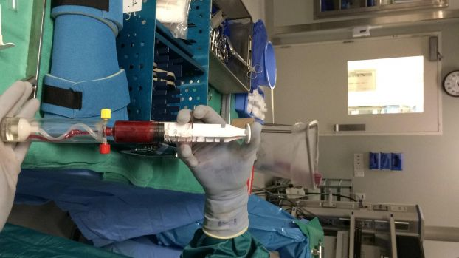
Photo By Kyrie O'Connor
The surgical team at Houston Methodist Hospital performs a rotator-cuff surgery that involves an injection of stem cells mixed into the patient s own bone marrow. This medical slurry acts like fertilizer to accelerate the healing process.

Top of Form
Bottom of Form

Top of Form
Bottom of Form
The first surprise in the rotator-cuff surgery, at least to an observer, is that the patient, while he's under general anesthetic, is propped into a sitting position. The patient, a 54-year-old man, has torn the rotator cuff - the muscles and tendons that help keep the shoulder stable - in his left shoulder, and it's Dr. David Lintner's job to fix it.
Lintner, his work displayed many times magnified on an array of flat-screens over the operating table at Houston Methodist Hospital, is minimizing the insult to the patient's body. First, through one of the holes he has to make in the bone, Lintner draws bone marrow. "We're taking advantage of it," Lintner says later of having to make the hole anyway. "We want to cause no extra trauma."
Into the holes in the bone, Lintner places small anchors. He sutures the rotator-cuff tendon to the bone. On the screens, the work looks huge, like tying ropes on a whaling ship, but in truth, it's tiny. In the operating room's background, classic rock is playing: Hendrix and late Beatles under the whir of the machines.
Meanwhile, at the other end of the operating room, the bone marrow and blood from the hole in the bone are placed on a boxlike machine that will concentrate the liquid. It's a great advantage, Lintner says, to be able to do that in the operating room rather than sending it out. "That's the advance here," he says.
The tying-down of the tendons continues until it's time for the final piece of the operation. Lintner takes the prepared bone-marrow slurry, rich with stem cells and platelets, and injects it into the shoulder. With a visible whoosh, the screens fill with red clouds.
Then it's time to close up the patient.
The gush of stem cell concentrate is a 21st-century-style miracle. But it's got zero whiz-bang factor: no fancy machines, no delicate work. "It's startlingly simple and a little bit anticlimactic," Lintner says.
The prepared bone marrow will act "like fertilizer" on the shoulder repair, he says, the stem cells and platelets and growth factors all acting to accelerate healing.
"There are lots of wonderful things in there that are helpful for healing," he says.
The surgeon expects the patient to recover well. "It's a very good prognosis," Lintner says. "The tissue is very robust."
Keith Sanborn has seen the operation from the other side. His left rotator cuff was operated on in 2009, without having an injection of stem cells. "I had a little more damage, but it took almost a year" to get function back, he says.
Last October, he had his right rotator cuff done, with an injection of his own stem cells. "I was 100 percent probably at four months," he says. He had full range of motion at three months.
"It was a cakewalk compared to the other one," says Sanborn, who is 50 and lives in Houston. "It definitely had something to do with the healing." The second repair also required markedly less physical therapy, once a week versus three times a week with the first surgery.
Nevertheless, Sanborn says he's gotten a little more realistic about pushing his body. "I've got to get it into my head that I'm not in my 20s anymore."

